**Team Name**: We Can Do It

**Date of Submission:** 10/24/2021

**Meeting Date & Time:** 10/22/2021 @ 6:00PM

**Meeting Location:** Zoom

**Meeting Duration:** 55 minutes

| **Team Members** | **X = Present** | **Notes** |
| --- | --- | --- |
| Dhari Alenezi | X |  |
| Abdulrahman Alharbi | X |  |
| Elina Do | X |  |
| Andrew Nguyen | X |  |

**Progress:**

**Team accomplishments for the week:**

This week we presented at City Hall for the Chief of the WPD and other department members. During the presentation, we were able to discuss some of the logistics of the project and ask them for any comments or feedback. We also worked on some of the feedback offered by the WPD during our first presentation. We were also peer reviewed two teams this week and were able to get reviewed by one.

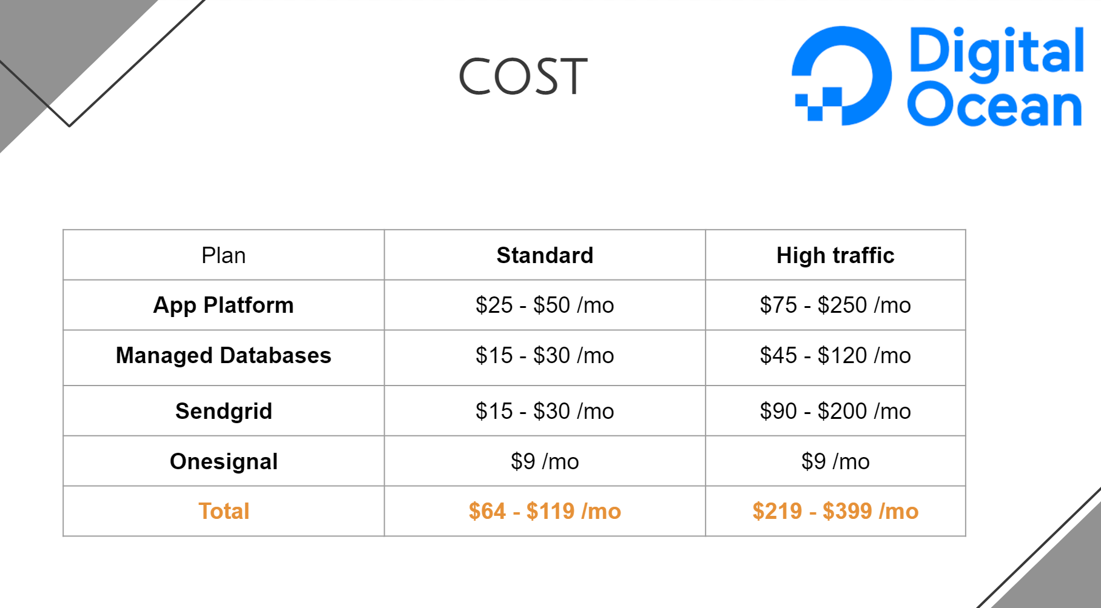

**Individual contributions:**

**Dhari Alenezi:** This week, I developed a categories feature, so I created new controllers on the backend side that are responsible for adding, showing, and removing the categories. Also, I analyzed the cost for running the application, and we presented this analysis on the presentation.

**Abdulrahman Alharbi:** I am looking into user guide manual templates and techniques for making user guide manuals. I am researching the best way of making a user guide manual.

**Elina Do:** Worked with Dhari on the categories model and added it to the diagram to better determine the fields needed. Set up two meetings with teams we needed to meet for the TPR.

**Andrew Nguyen:** Finalized dynamic page of site to display data from case/user informationion. Started working on better design to display the information.

**Project Tracking:**

| **Team Member** | **Assignment** | **Due Date** | **% Complete** |
| --- | --- | --- | --- |
| Dhari Alenezi | Developing category screen | 10/22/2021 | 100% |
| Dhari Alenezi | Test the application on the Web and the Windows platform. | 10/30/2021 | 10% |
| Abdulrahman Alharbi | Working on building user guide manual | 11/18/2021 | 5% |
| Elina Do | Complete first draft of base code for database in MongoDB | 09/17/2021 | 50% |
| Andrew Nguyen | Create static web prototype for WPD to test and give feedback on | 09/19/2021 | 100% |
| Andrew Nguyen | Link web app with back end to display information | 10/06/2021 | 100% |
| Andrew Nguyen | Minor Improvement for dynamic page of web app to present the data | 10/22/2021 | 100% |
| Andrew Nguyen | Add in a search function to search up the case detail with the unique ID | 10/30/2021 | 70% |

**Plan:**

| **Assignment** | **Due Date** |
| --- | --- |
| Support web application | 10/27/2021 |
| Try & test NFC technology (Near-field communication) | 10/30/2021 |
| Developing the cache feature for the mobile app | 10/31/2021 |
| Testing both the frontend & backend sides | 11/7/2021 |
| Web App final review | 11/14/2021 |
| Web App finalized and ready for presentation | 11/28/2021 |
|  |  |
|  |  |
|  |  |
|  |  |
|  |  |

**Issues:**

Include the schedule for the next meeting:

Meeting Date & Time: 10/29/2021 @ 6:00PM

Meeting Location: **Zoom**